**Class Practice - 3**

**MIS 64038**

1. Plot this graph using ggplot()

**ggplot(cars, aes(displ,cty)) +**

**geom_point(colour="orange") + facet_wrap(~class)**

1. Use facetting to explore the 3-way relationship between fuel economy, engine size, and number of cylinders.

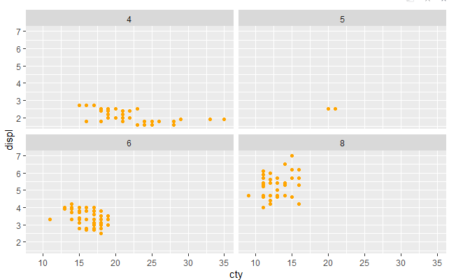

1. How does facetting by number of cylinders change your assessment of the relationship between engine size and fuel economy?

The relationship seems to vary by number of cylinders.